
University Institute of Engineering Department of Computer Science & Engineering
DM (CST-352/ITT-352)

Assignment-3

Complex Questions for Fast Leaners

Q1. If the distance d(u, v) between two vertices u and v that can be connected by a path in a graph is defined to be the length of the shortest path connecting them, then prove that the distance function satisfies the triangle inequality: d(u, v) + d(v, w) ≥ d(u, w). (CO-5)

Q3. Write the Prim’s algorithm and find the minimum spanning tree from graph shown in Figure
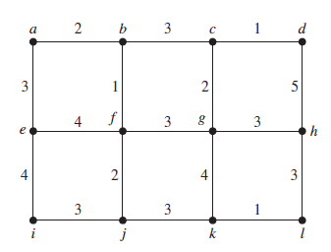
. (CO-5)

Q4. . Find the length of a shortest path between a to z in the given weighted graph. By Dijkstra’s algorithm

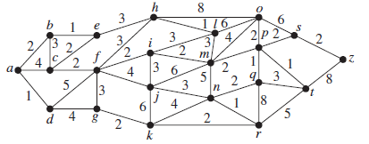
. (CO-5)

Instructions
- Each Question carries 2.5 Marks
- High Plagiarism can result into cancellation of Assignment.
- Try to explore your answer with your creative thinking.
- All Assignments should be written on A4 sheets left hand side scaled manually and strictly written one side only.
- All Assignment must have front page entitled your name, UID number, Batch/Group number.
- Use of Chat GPT/Bing AI/Chat sonic/Chinchilla/ Dialo GPT or any such AI based technology can result into cancellation of Assignment.

